A, B & C SIZE ARROW BOARD

OPERATING AND INSTALLATION INSTRUCTIONS

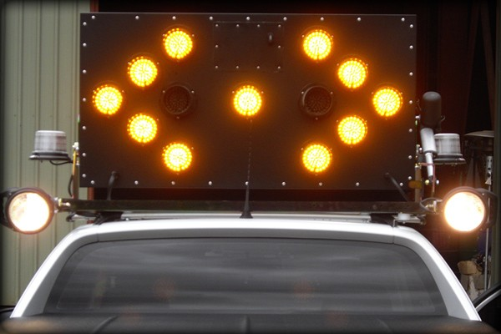

Table of Contents

1. Maintenance and Cleaning......................................................... 3

2. Operational Instructions ............................................................ 4

2.1 Using the Arrow Emergency System’s Remote ............... 4

2.2 Setting the Arrow Board: Gas Strut................................. 5

2.3 Setting the Arrow Board: Motor Lift ............................... 5

2.4 Warning Lights ................................................................ 5

3. Spare Parts List ........................................................................... 6

4. Suction Cup Installation Instructions.......................................... 7

5. Wiring Arrow Board to Battery ................................................ 10

6. Service and Warranty Claims ................................................... 13

7. Limited Warranty…………………………………………………………..………13

Page | 2

Note
This operating manual covers both 12v and 24v Arrow Boards (A and B sizes).

The voltage of the Arrow Board can be determined by the wires connecting to the battery
– Blue (12v) and Red (24v).

The maximum viewing distance of a B size Arrow Board is 860m, while an A size Arrow
Board is 500m.

1. Maintenance and Cleaning

Initial inspection of the Arrow Board is required before operating the equipment at the start of each shift. After reading and understanding the operation described in this manual, the most important inspection is to make sure the lamps are clean and all functions are working. If a build-up of dust or dirt is noticed on the lamps then the following cleaning method must be followed:

CAUTION
Proper safety precautions must be followed before accessing the Arrow Board. Please check with the relevant operational staff prior to performing any maintenance or cleaning of the Arrow Board.

Do NOT use solvent based or abrasive cleaners as damage to the clear lens of the LED will occur.

When it is deemed safe to access the Arrow Board for cleaning and all safety precautions required at your workplace are met use warm soapy water and a clean cloth, rinsing frequently in fresh water to clean each lamp and the sensor. Rinse off residual soap with clean water.

Page | 3

2. Operational Instructions

Thank you for purchasing an Arrow Emergency Systems’ Arrow Board.

Depending on the Arrow Board that you have purchased it will either operate via a Gas Strut or a Motor Lift. For information on a Gas Strut please see “Section 2.2 Setting the Arrow Board: Gas Strut”. For information on a Motor Lift please see “Section 2.3 Setting the Arrow Board: Motor Lift”.

2.1 Using the Arrow Emergency Systems Remote

Depending on the type of Arrow Board you have purchased, your remote control will contain various push buttons that correspond to each function. If you have purchased an Arrow Board with beacons and work lights, these can be turned on by pressing the buttons.

For Arrow Boards that have motor lifts installed hold the “RAISE” button until the LED next to the button flashes. This will continue to flash until the Arrow Board is upright, once fully upright the LED will be a solid colour. To lower the board press the “LOWER” button.

The rotary switch is used to select the different arrow modes. To turn the board on, turn the rotary switch clockwise to the desired arrow mode and then press the “SET MODE” button
to display the arrow. Once you have finished using the board turn the rotary switch counter- clockwise to switch the board off.

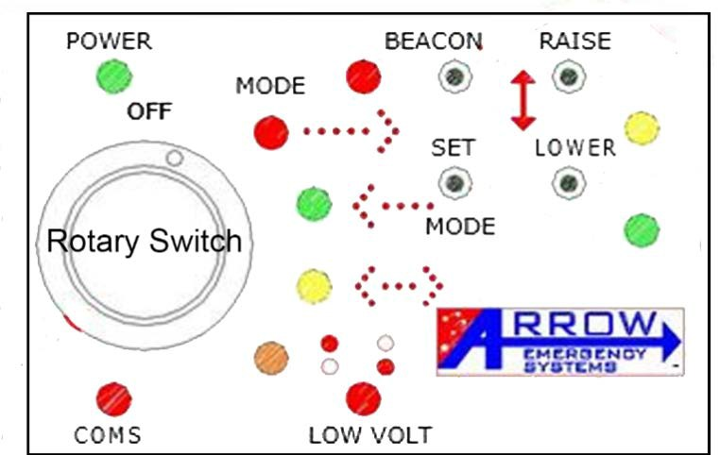

Page | 4

2.2 Setting the Arrow Board: Gas Strut

1. Pull down on the release catch to allow the board to rise.

2. Once the board is raised to the upright position, turn the rotary switch clockwise until the desired arrow function is selected on the control board. Then press the “SET MODE” button to display the arrow.

3. On the completion of the job power the board off by turning the rotary switch counter- clockwise and gently pull down on the rope to return the Arrow Board to travel position.

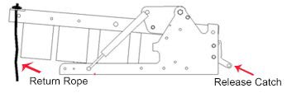

2.3 Setting the Arrow Board: Motor Lift

1. Hold the “RAISE” button until the LED beside the “RAISE” button flashes.

2. Once the board is raised to the upright position, turn the rotary switch clockwise until the desired arrow function is selected on the control board. Then press the “SET MODE” button to display the arrow.

3. On completion of the job power the board off by turning the rotary switch counter- clockwise and press the “LOWER” button

Caution
When using an Arrow Board equipped with Motor Lift, a speed limit of 40KM must be observed when the Arrow Board is raised.

2.4 Warning Lights

LOW VOLT: If the battery falls dangerously low then the arrow will revert to the diagonal or hazard flash mode. Changing patterns will have no effect. In order to continue use, the Battery Voltage must be restored to 12.5V or 24.5V depending on your Arrow Board Voltage.

COMS: Indicates a major fault. Please contact Arrow Emergency Systems on (07) 3881 3302 or 041 373 0085 for further support.

Page | 5

3. Spare Parts List

LED Lamp

LED Shroud

Switch PCB – Hand Remote Control Switch Box – Hand Remote Control Box PCB Board
Light Sensor

Motor Lift Actuator

Gas Strut

Wind Deflectors Arrow Board Channel Arrow Board Side Frame Suction Cup Mounting Kit Beacons
Beacons Plates

Ute Frame

Roof Bracket

Please note:

If a fuse is to be replaced use a 10amp automotive blade fuse.

Page | 6

4. Suction Cup Installation

This section provides installation instructions to mount your Arrow Board using the Suction Cup method. If you have any difficulties installing this product please contact us on (07) 3881 3302 or alternatively 0413 730 085.

Alternative mounting options available includes ute frame and cage mount. Please contact Arrow
Emergency Systems for further information regarding these alternative options.

Installation Instructions

If the Arrow Board Channel is already bolted onto the front arms of the Arrow Board please skip step
1.

1. When delivered on a pallet the Arrow Board channel is left off. Bolt the Channel on to the side arms using the three predrilled holes at the front of the arm. Using six M8X20 bolts twelve M8 washers and six M8 locknuts (please see picture- the channel sits between the two washers).

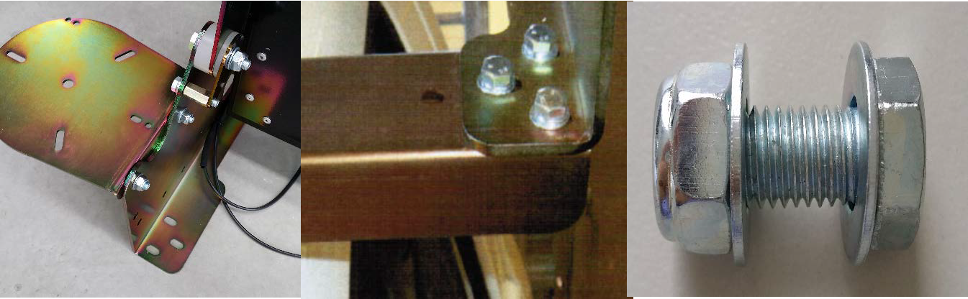

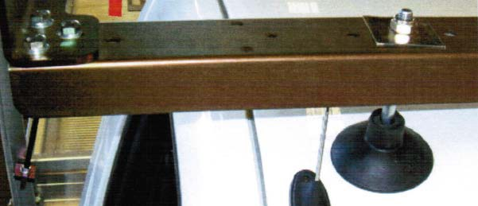
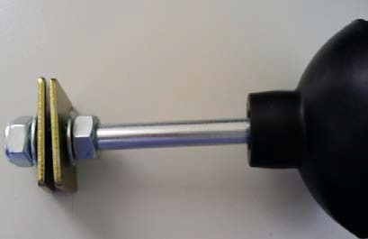
2. Examine your ute roof and determine the position of your suction cup. It is important to place your suction at the strongest point of your roof, this is usually near the edge of the roof. Depending on where the suction cup will be placed, either use the predrilled holes or drill an additional 8mm hole into the Arrow Board channel. Secure tightly using four M8 washers, two M8 locknuts, two M8 locknuts and four 35mm square plates (please see picture- the channel sits between the two 35mm square plates).

Page | 7

3. Sit the Arrow Board’s back side arms onto the ute headboard, ensuring it is centred. Ensure that the suction cups are placed at the strongest section of your ute roof. Secure tightly onto the ute back frame using the two predrilled holes on both side arms with four M8X25 bolts, sixteen M8 washers and four M8 locknuts (please see picture- the ute frame sits between
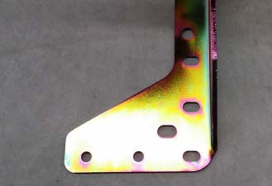
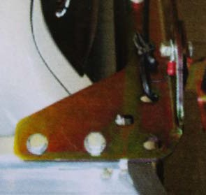
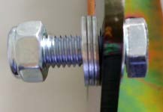
the locknut and the three washers).

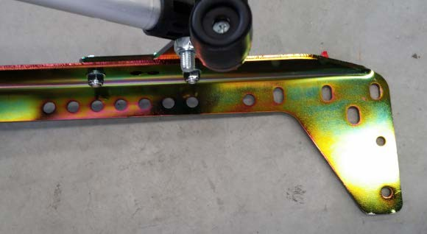
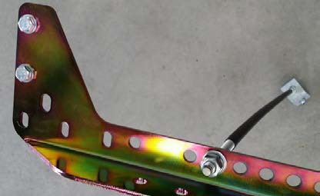
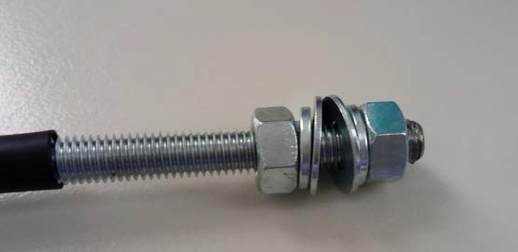
4. Secure the rod onto the second last hole of the Arrow Board arm (please see picture – the arm sits between the two washers) leaving 10mm protruding out of the top locknut for both left and right side arms.

Page | 8

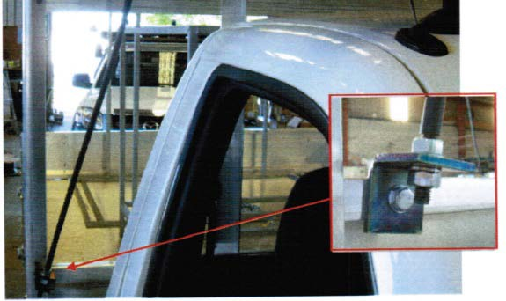
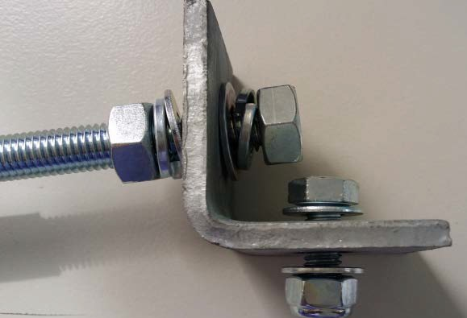
5. Drill an 8mm hole into the ute back frame in line with the ute cab. Secure the angle bracket to the Ute head board with two M8X20 bolt, four M8 washers, two M8 locknut (please see picture – the ute frame sits between the angle bracket and washer). Do this on both sides.

6. Tighten the locknut attached to the angle bracket. A curve in the rods will become apparent as the locknuts are tightened. Tighten the locknut until the rod takes the majority of the downward pressure of the Arrow Board and that the suction cups are just touching the roof. Please note if the locknut is too tight the suction cup will lift off the roof, therefore it is important to tighten it only enough to ensure the suction cups are just touching the roof. Do this on both sides.

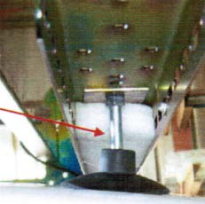

Page | 9

5.Wiring the Arrow Board to Battery

This section provides instruction to wire the Arrow Board to the Battery. These instructions are designed for a standard board with actuator and beacon. If your installation differs from the instruction or have any difficulties installing this product please contact us on (07) 3881 3302 or alternatively 0413 730 085.

- Once the Arrow Board is correctly mounted you may proceed to wiring the Arrow Board to the ute (Data cable to control box, black = ground , orange = beacons, yellow = motor, Blue = 12V or Red = 24V Arrow Board and tan = work light ).

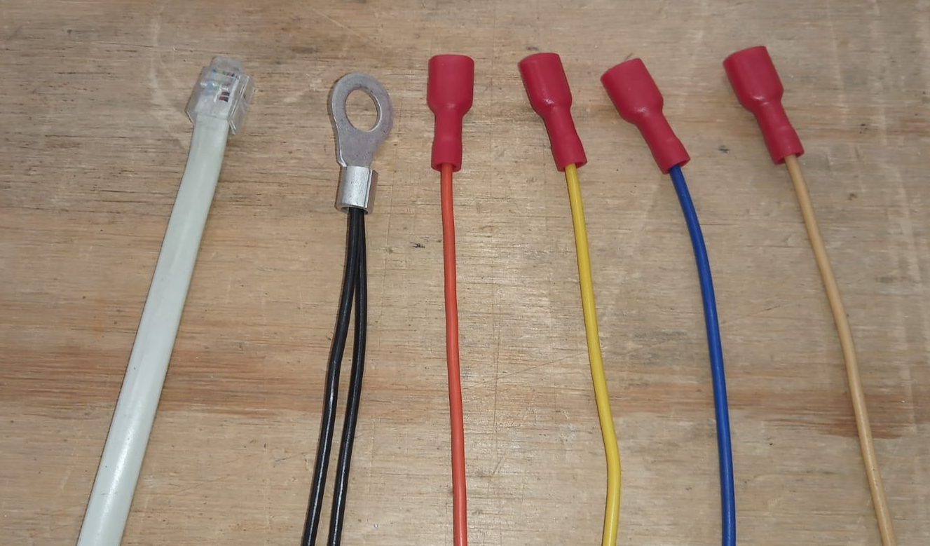

2. Once your board is mounted onto the ute run the wires from the Arrow Board into the Ute cab. The method will depend on your vehicle, however these steps will go through the most common wiring method for utes.

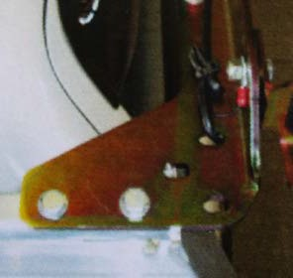
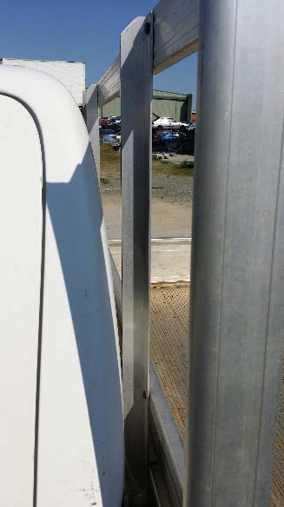
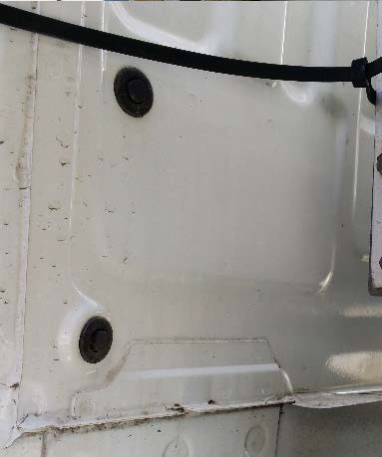
3. Run the wires across the Arrow Board side arm and down one of the holes at the back of the arms. Attach the wires using zip ties to the ute backboard frame and thread into the hole at the back of the ute cab. It is important that you leave enough slack on the wires so that the Arrow Board can move freely up. Run all the wires minus the data cable through the ute cab into the engine bay through a hole behind the glove box.

Page | 10

4. Mount fuse box to passenger side inner guard with two self-drilling/ tapping screws.
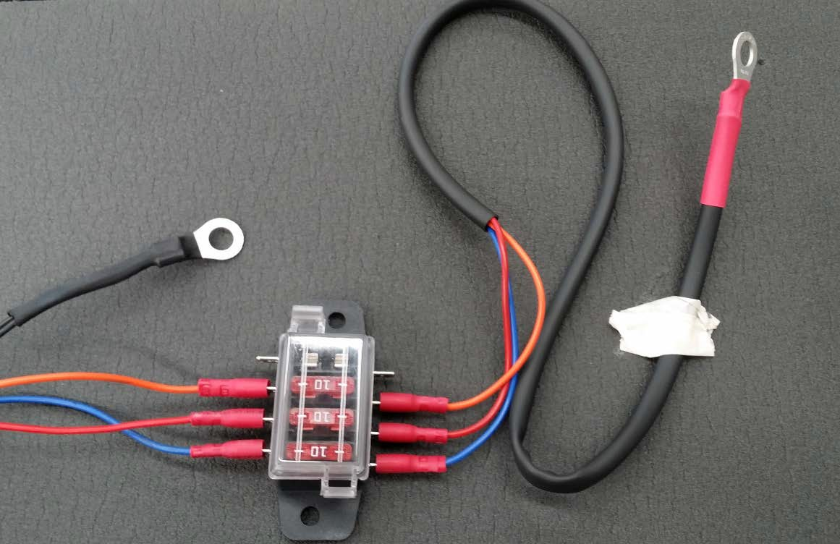
Attach Arrow Board wires to the fuse box that contain the 10amp fuses. Fit end of fuse box harness (8-8 terminal) to positive battery terminal (12mm locknut on positive terminal).

Earth by fixing to engine chassis.
To positive battery terminal.

Arrow
Board wires.

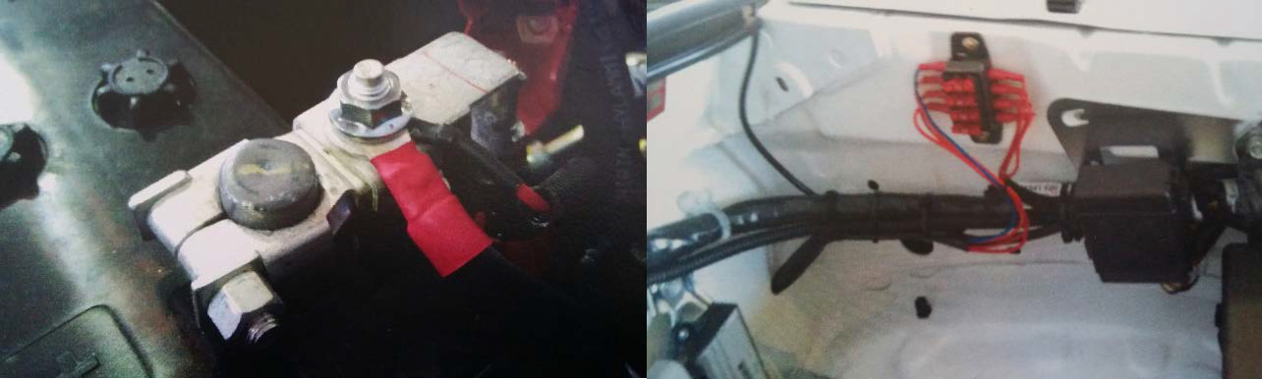

Please Note
Place 8-8 terminal on top of all other terminals. Smaller terminals will pull in to the thread of 12mm locknut and ruin the thread

Page | 11

5. Once you have worked out where you want to place the control box thread the telephone cable into the back of the box and either screw or tape in place using the materials provided. Attach the cord to the back of the remote board. Then attach the remote board onto the case using the screws provided.

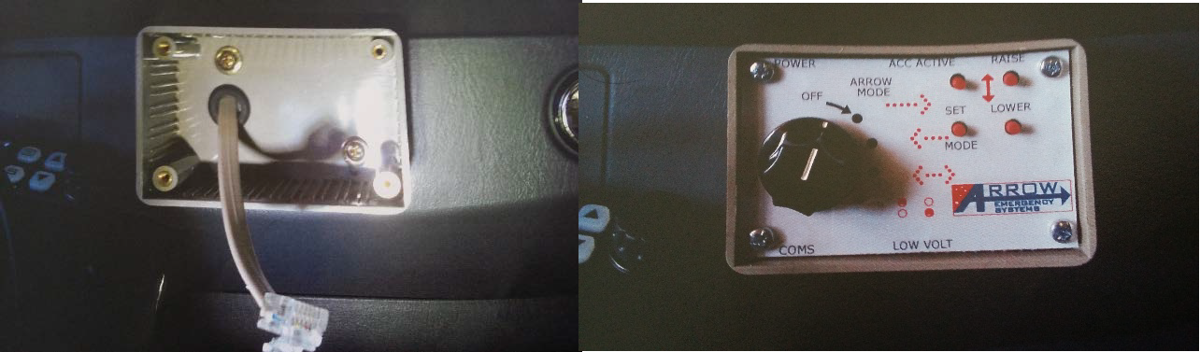

6. Once your wiring has been completed seal all the grommet holes with sikaflex sealant (engine bay/ rear ute cab). Test all Arrow Board functions are working correctly.

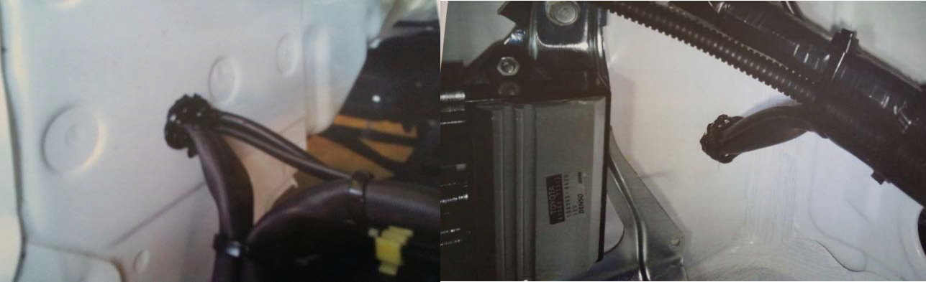

Page | 12

6.Service and Warranty Claims?

For service, warranty and spare parts please contact (07) 3881 3302 or 0413 730 085. It would be most helpful to quote the board’s serial number when contacting us.

The unique serial number for each board can be found on the bottom left side of the Arrow
Board (passenger seat side) engraved near the wire entry point.

7.Limited Warranty

The LEDs have a warranty for 12 months. If within this period there is a demonstrable reduction in the light output of greater than 25% then the LED will be supplied free.

Other electrical and mechanical parts have a warranty of 12 months against defects in manufacture.

All warranty are ex-factory.

Page | 13

Arrow Boards

Variable Speed Limit Signage Variable Message Signs Pilot Vehicle Signs Accessories & Spare Parts Installation Services
Custom Installations

Custom made Products

Repair & Maintenance Services

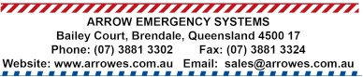
Pag

e | 14

